Tableau Visualization of IPL data warehouse

1.Taking Match Fact table and Date Dimension table to create one hierarchy on date (Year, Month, Day)

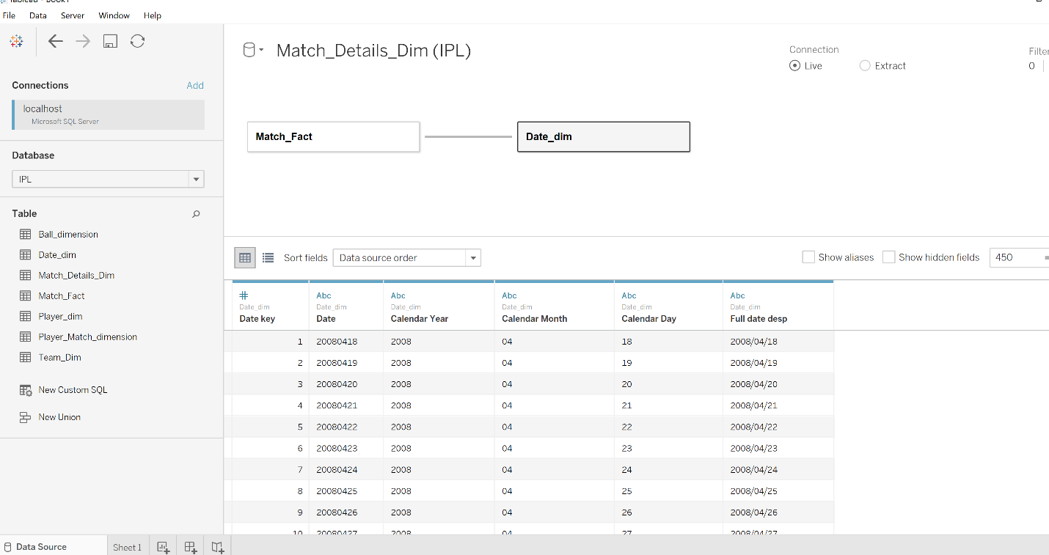

Date Hierarchy created in tables

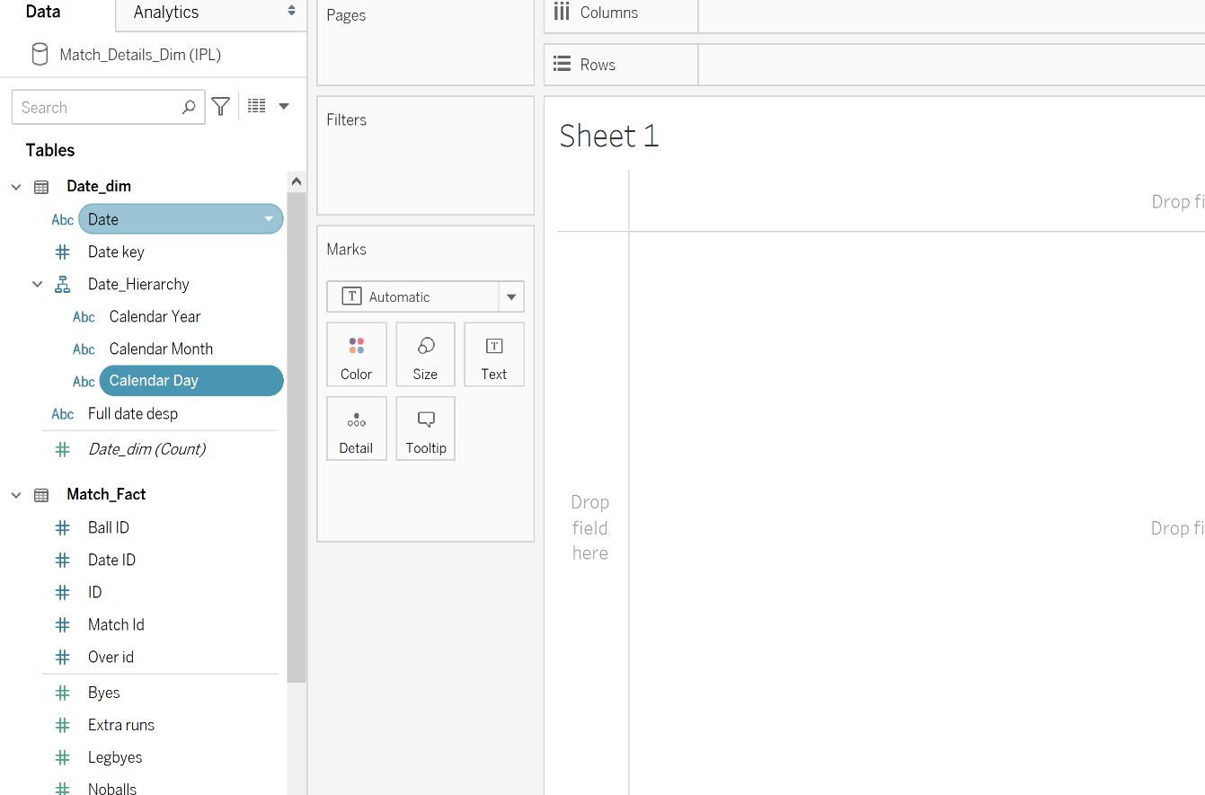

This is representation of in each year (from 2008 to 2017) when matches are played what was the run scored by all team for each month

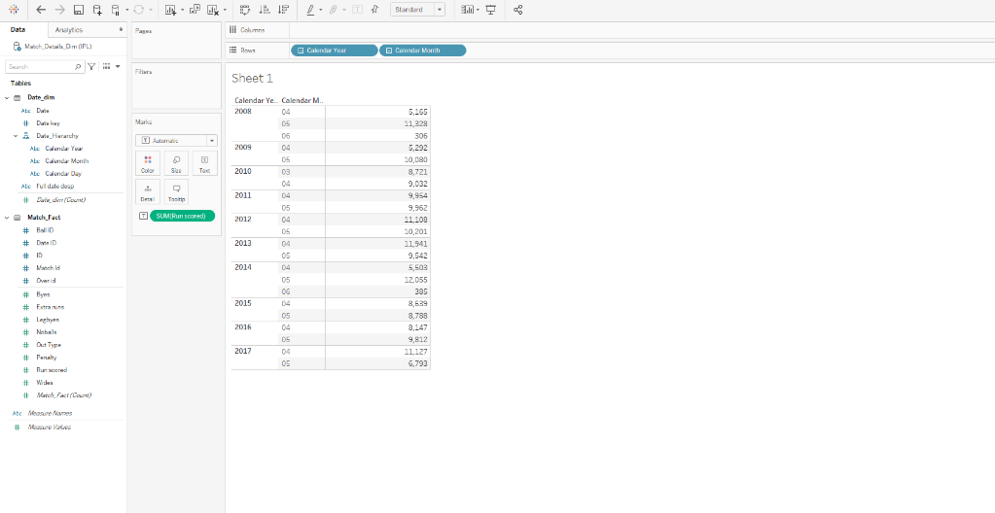

Visualization of total run scored by each team each year and respective month.

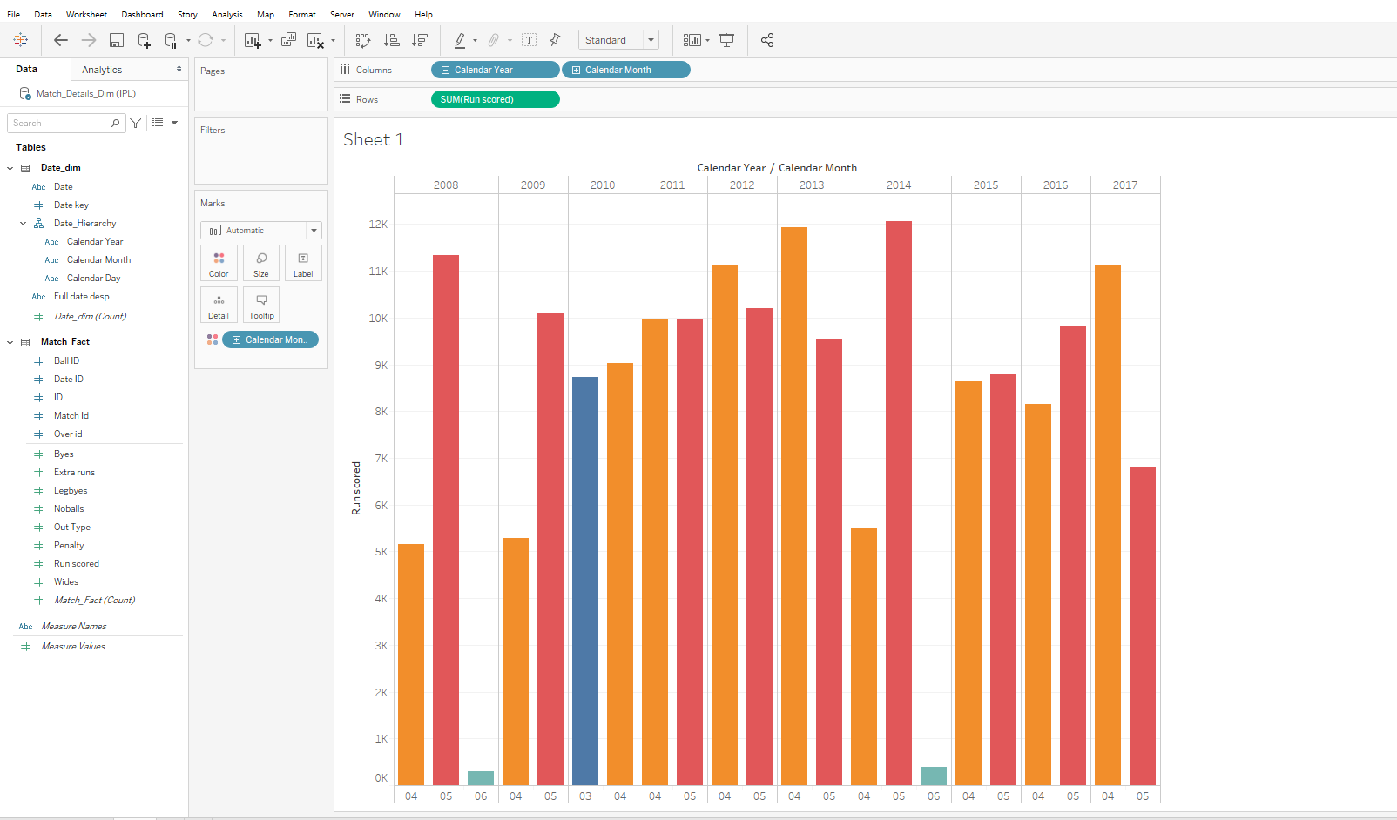

2.To get players details added one more new table with fact table and date table i.e Player match dimension

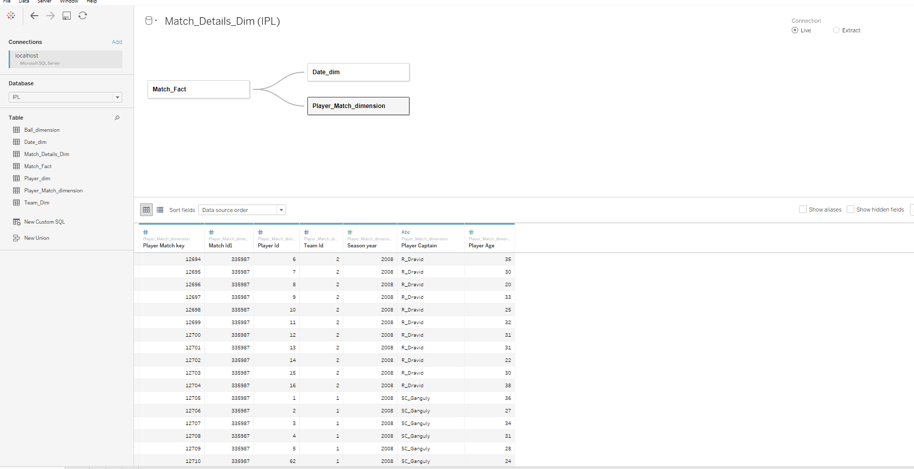

Representation of each teams captain run scored per year

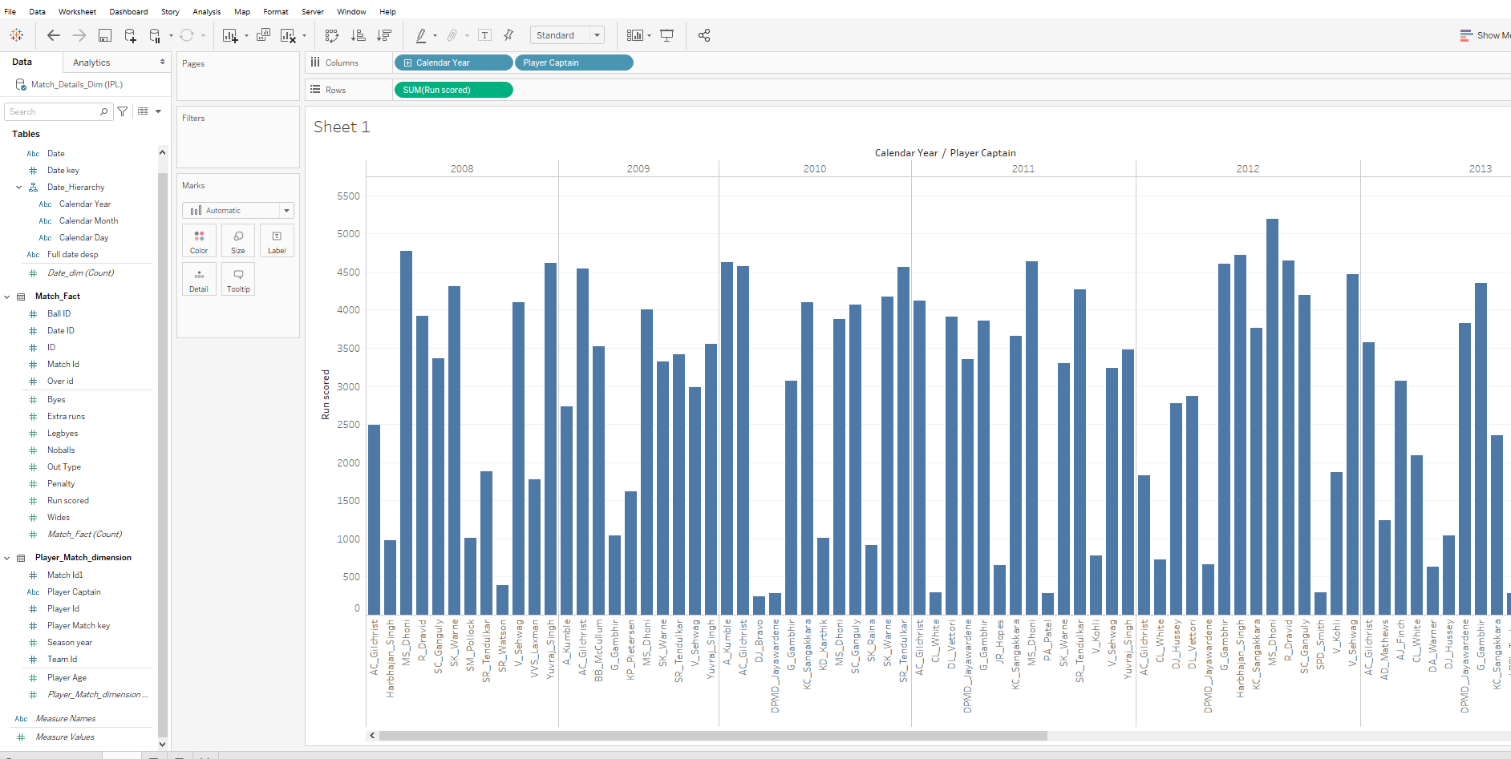

Adding filter on calendar year to get data of corresponding year

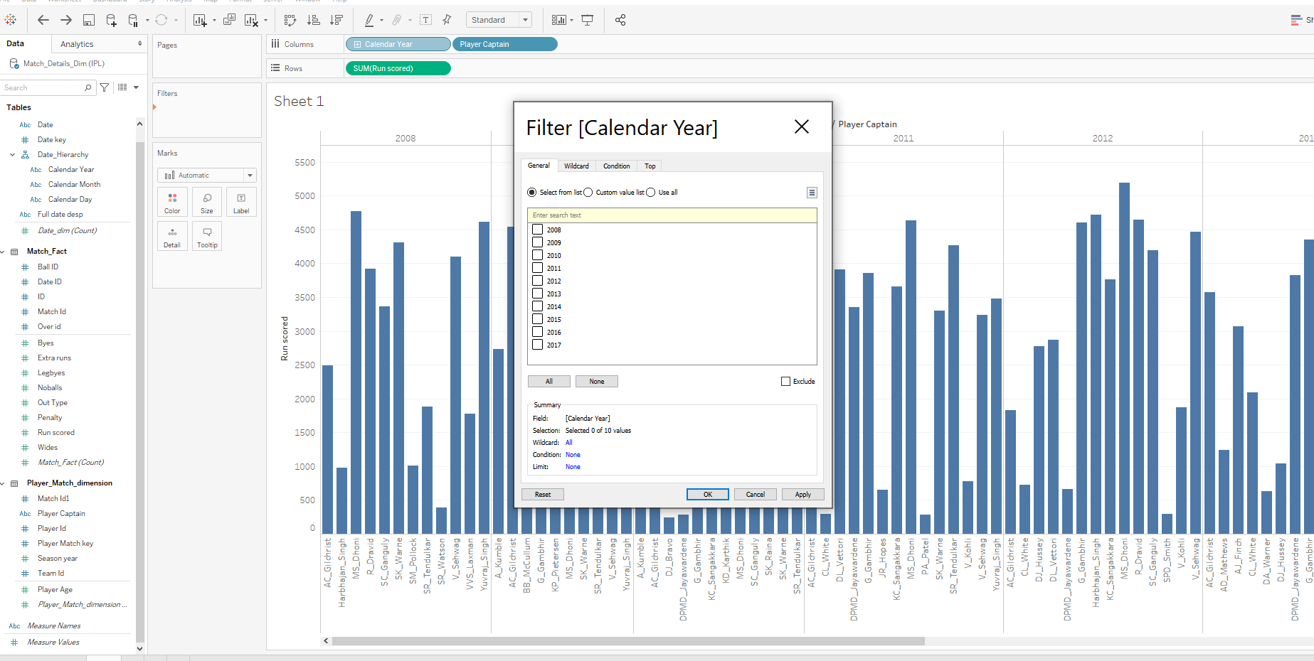

For Year 2017 run scored by each captain

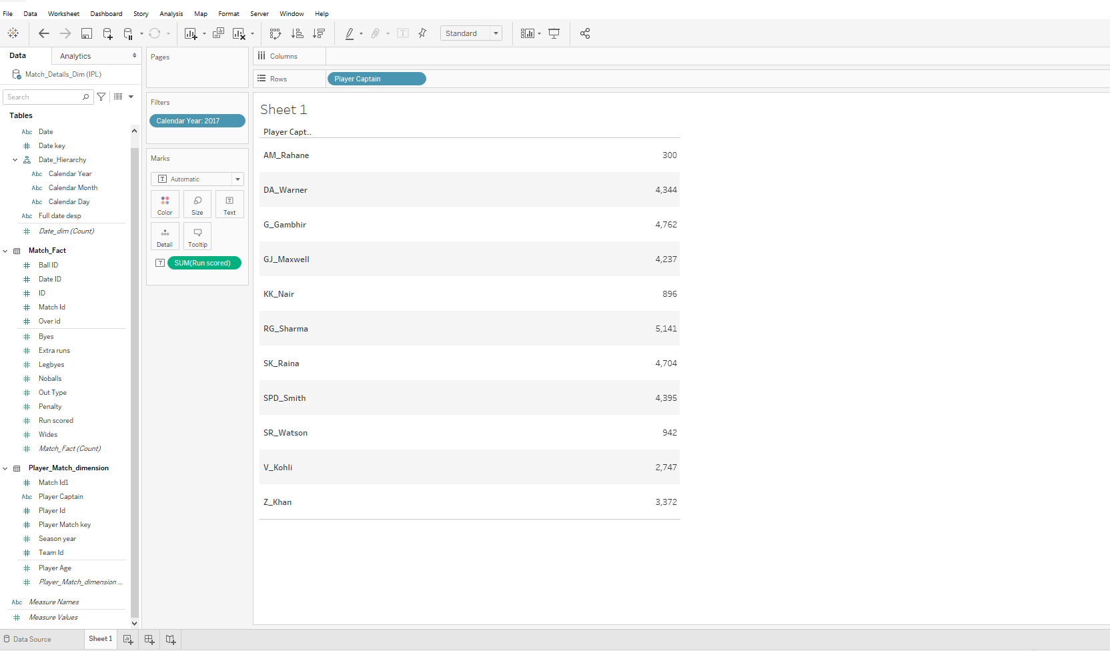

Graph presentation of the same

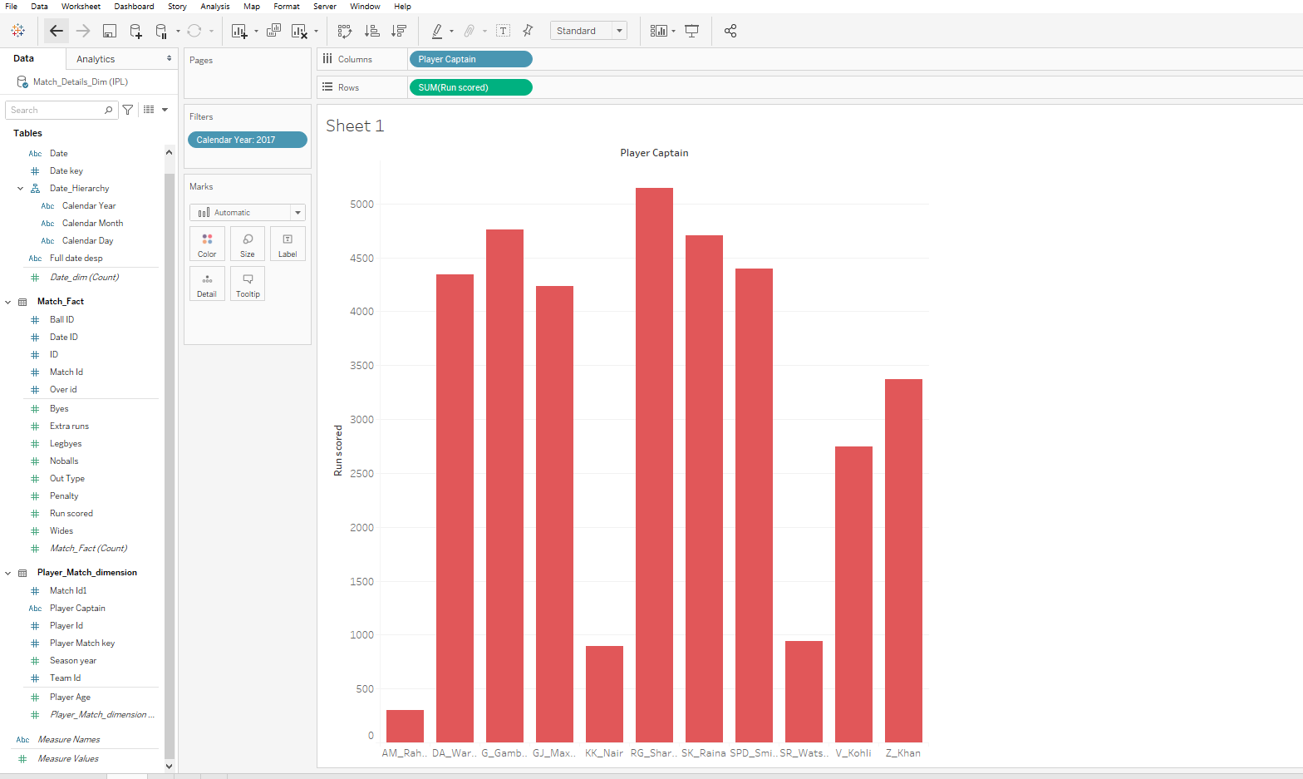

3.Creaeted and calculated filed which will give percentage of extra runs per year compare to runs scored by all teams per year

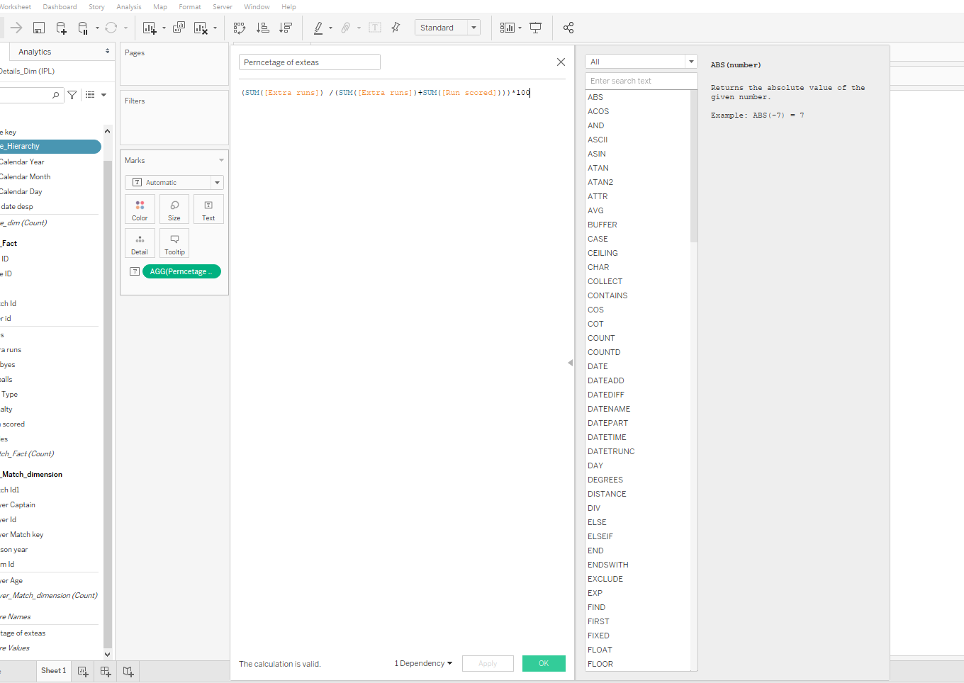

For each year percentage of extra runs

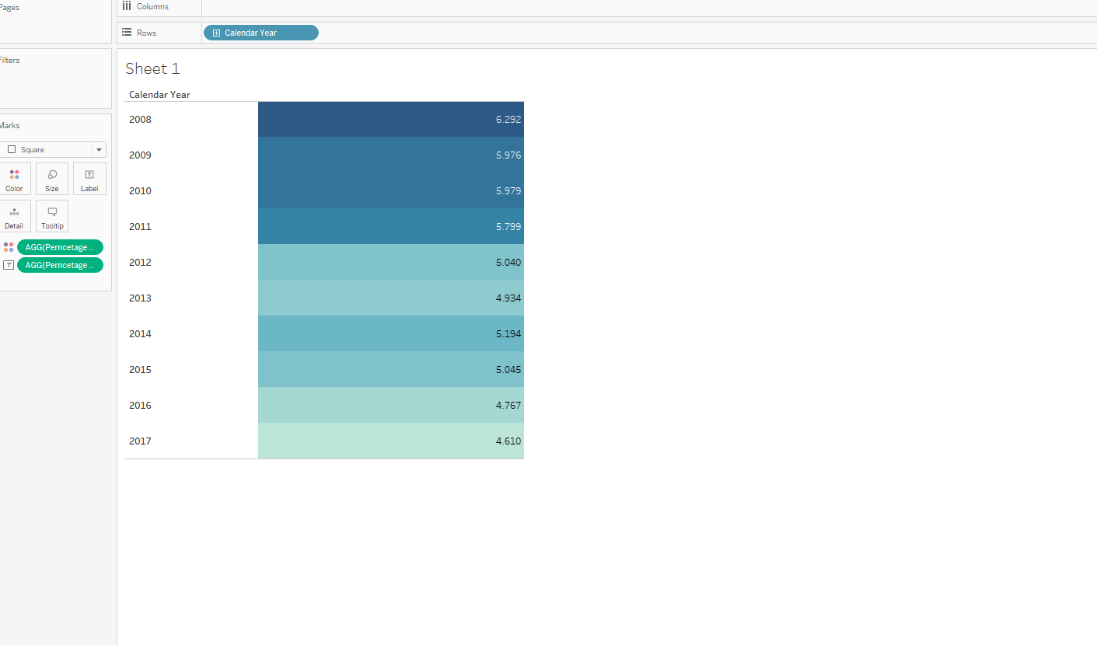

Above data in Graph format

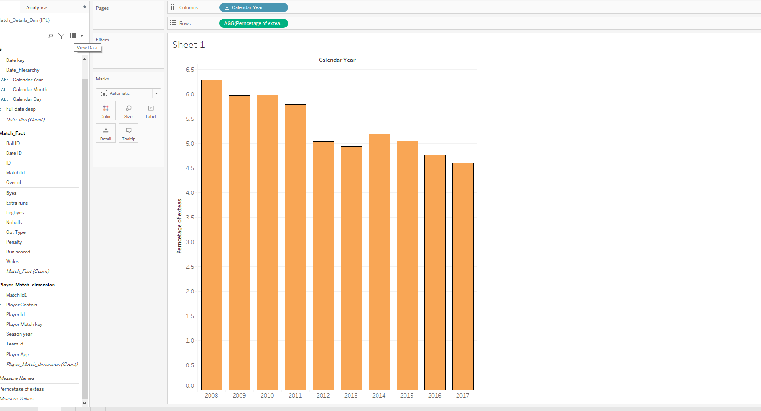

4.Data of How many matches won by per team per year (the one has highest value will be winning team of that year)

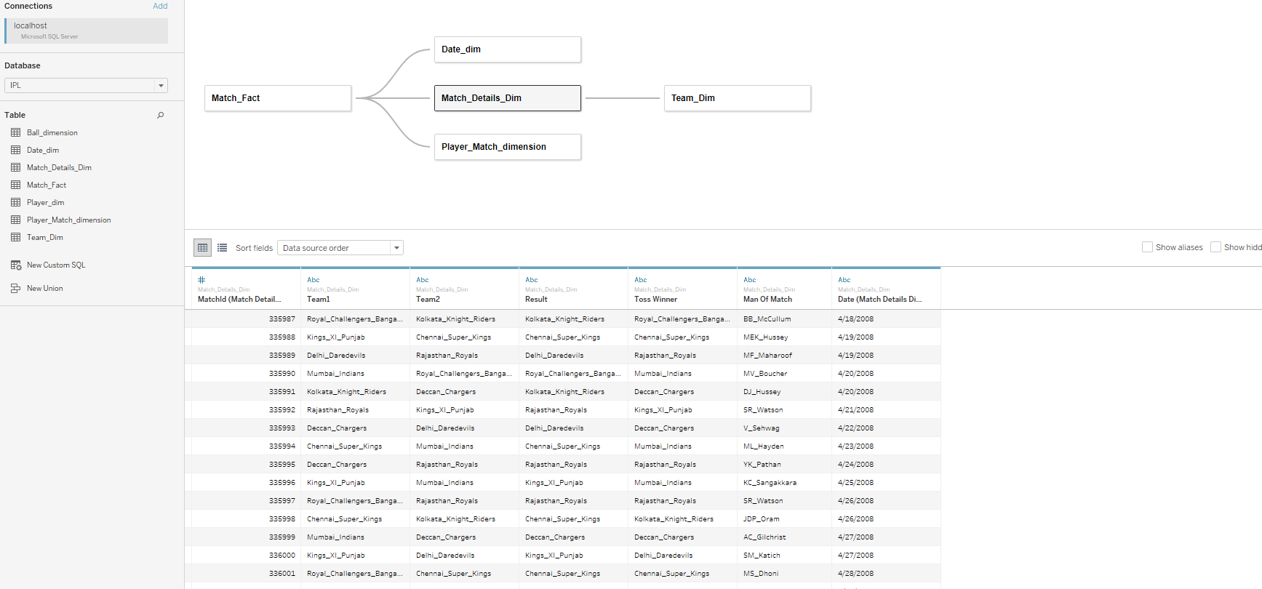

Numeric value for each team winning count per year

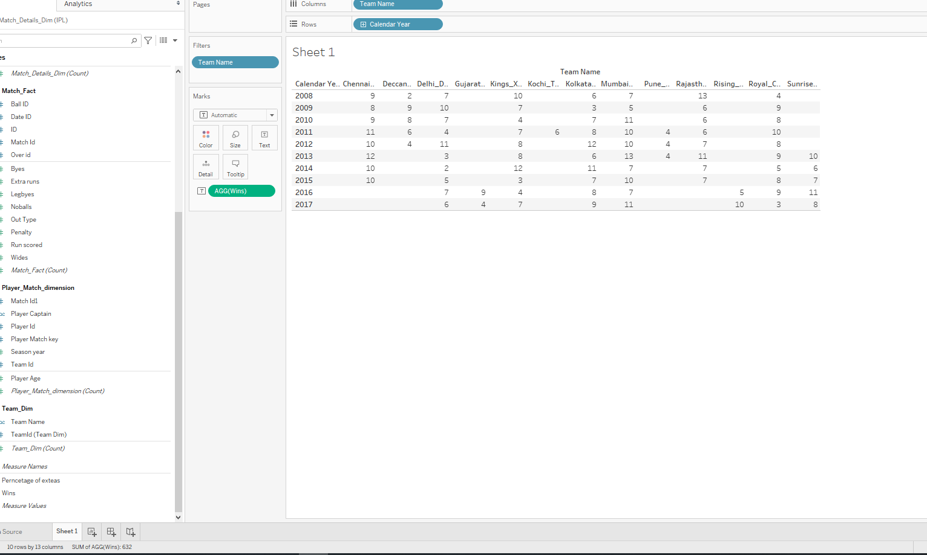

Above data in Graph format

